Project #5 Verification

Analog Measurements  
Cooper Brotherton  
Instructor: Dr. Michael Jo  
ECE230-03

# Requirements

* The analog voltage is sampled at a 1Hz rate.
  + ADC uses a 14-bit resolution.
  + The analog value is computer to the nearest mV.
  + The analog-to-digital conversion is within 0.1V of the measured voltage.
* The analog and digital values are displayed on the LCD in the format specified.
  + The analog voltage values include leading zeroes where appropriate.
  + Digital values may include leading zeroes or spaces.
* ISRs are brief and do not contain lengthy computations or interactions with the LCD.
* The floating-point unit is enabled for analog voltage computations.
* The potentiometer circuit is connected to the analog input A15 and provides a full range of 0 to 3.3V.
* The LCD is interfaced in 8-bit data mode.

# Advanced Requirements

* The requirements from above, except where noted.
* The active analog channel is set to A15 upon system start.
* Pressing S1 toggles the analog channel selection between A15 and A14.
  + The switch is debounced to ensure single toggle for each press-and-release of S1.
  + The display is updated as specified for the active analog channel.
* The photoresistor circuit is connected to the analog input A15.
  + The circuit uses a 1kΩ resistor in series with a photoresistor.
  + The analog input nears 3.3V in dark environments.
  + The analog input nears 0V in bright environments.
* The LCD is interfaced in 4-bit data mode.

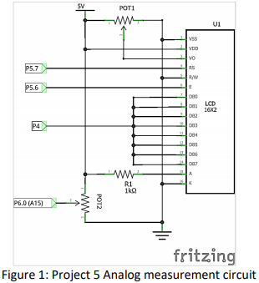

Figure 1 – Circuit Diagram

 or 

Figure 2 – LCD Analog Output

# Test Plan

The following details a plan for testing the specifications.

|  |  |  |
| --- | --- | --- |
| Test | Procedure | Pass/Fail Criteria |
| 1 |  |  |

# Verification

## Test 1

TODO